Thursday, 24 November 2022

Abstract

Submitted in partial fulfillment of the requirements of the software engineering course  
Habiba Amr 2020/08121  
Noran Essam 2020/07406  
Rana Ehab 2020/15051  
Mariam Maged 2020/00559  
Belal Adel 2020/11213

Software Documentation v6.0

For Productivity Manager System

Contents

Introduction 3

Purpose 3

Scope 3

Glossary 3

Document Overview 4

Overall Specification 5

System Environment 5

System Context Diagram 5

Use Case Diagram 6

Functional Requirements Specification 7

Non-Functional Requirements 7

Use Cases 8

Log In 8

Add User 9

View Users 10

Update User 11

Delete User 12

Add Employee 14

View Employees 16

Update Employee 17

Delete Employee 18

View Cross-utilized Employees 19

View Over-utilized Employees 20

Add Project 21

View Projects 22

Update Project 23

Delete Project 24

Assign Project Leaders 25

Add employees to project teams 26

Mark Project as done 27

Update Project Capacity 28

Update Employee Utilization on Project 29

View statistical details 30

Sequence Diagrams 31

Add new Project 31

Add New User 32

Assign Employee to project 33

Update employee utilization On Project 34

View employees 35

View Projects 36

View project statistics 37

View Employee Statistics 38

Designs 39

Class Diagram 39

Object Diagram 40

Database Physical Design 41

Prototype 42

1- Admins can manage users' data. 42

2- Admins can manage projects' data. 44

3- Team leaders can add or remove employees to their team. 45

4- Team leaders can add the required employee capacity to their team members. 46

5- Team leaders and Admins can view a List of all the projects and their data 46

6- Admins and team leaders can view statistical details 47

7- Admins can manage employees 47

# Introduction

## Purpose

The purpose of this document is to present a detailed description of the Productivity Manager. It will explain the purpose and features of the system, the interfaces of the system, what the system will do, the constraints under which it must operate and how the system will react to external stimuli. This document is intended for both the stakeholders and the developers of the system.

This document defines the system design for this productivity management system. It should illustrate how classes will be structured and arranged and how they will communicate.

## Scope

This system is a productivity enhancing tool that keeps track of projects data, employees’ work utilization. This system is a web-based application that provides interfaces for various stake holders (project leaders, managers/admins, employees).

This system’s admins can add new recruits to the employee pool where they’d be assigned to projects according to the respective project leader’s request. The admins can monitor the current work utilization of employees and view over-utilized and cross-utilized employees to better divide their workloads if possible and/or necessary. This system’s admins can also view the status and punctuality of projects. The system uses a lazy delete implementation to save historic data. The system aggregates relevant and useful statistics to support data driven decision making regarding how workload is managed within the department.

## Glossary

|  |  |
| --- | --- |
| Term | Definition |
| User/ Actor | The end user of the system. This user can either be an admin or a project leader. |
| Project leader | The user in charge of managing projects. This user can operate on their project data as well as view other projects and employees. |
| Admin | The user in charge of the system. This user can operate on user, employee, and project data. |
| Employee | The human resource which is utilized for projects. |
| Utilization | The amount by which the employee is busy with work. |
| Cross-utilization | The state where an employee is working on multiple projects at once. |
| Over-utilization | The state where an employee is overtasked. |
| Project Capacity | The number of employees needed for the project. |
| Statistical details | Collections of information extracted from saved data. |

## Document Overview

The Overall Description section of this document gives an overview of the functionality of the product. The system environment chapter describes the informal requirements and is used to establish a context for the technical requirements specification in the next chapter.

The Requirements Specification section of this document is written primarily for the developers and describes in technical terms the details of the functionality of the product.

Both sections of the document describe the same software product in its entirety but are intended for different audiences and thus use different language.

The system structure is described in the class diagram. An example of instances is described in the Object Diagram. The physical database ERD is also included.

# Overall Specification

## System Environment

### System Context Diagram

### Use Case Diagram

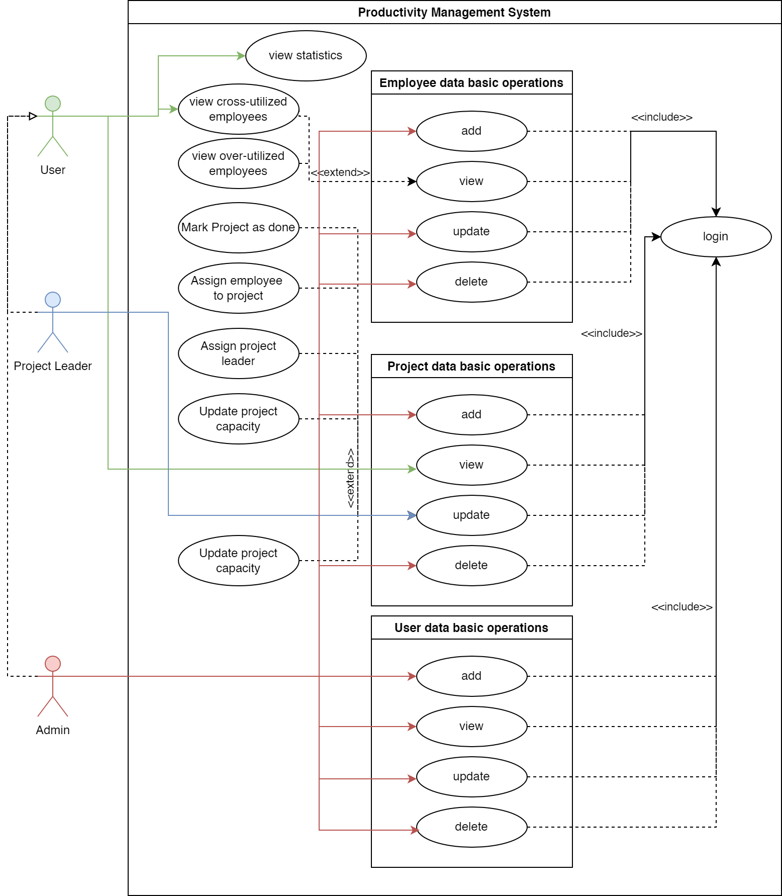

## Functional Requirements Specification

|  |  |  |
| --- | --- | --- |
| ID | Description | Comments |
| R0 | Admins can manage users' data. |  |
| R1 | Admins can manage projects' data. |  |
| R2 | Team leaders can add or remove employees to their team. |  |
| R3 | Team leaders can add the required employee capacity to their team members. |  |
| R4 | Team leaders and Admins can view a List of all the employees and their data |  |
| R5 | Team leaders and Admins can view a List of all the projects and their data |  |
| R6 | Admins and team leaders can view statistical details | Statistical details include: Employees’ utilization distribution, programming languages, average utilization of programing languages, projects distribution by regions, cross utilization distribution. |

## Non-Functional Requirements

* User friendly interface with simple readable and simple statistics.
* Our system has high speed efficiency.
* Our system is combatable with other operating systems.

## Use Cases

### Log In

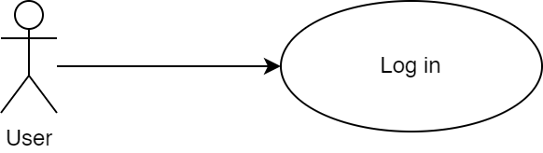

|  |  |
| --- | --- |
| Property | Value |
| ID, Name | UC1, Log in |
| Goal | A user should be granted access to the system through giving their email and password. |
| Initiator | Any user |
| Precondition | None |
| Postcondition | * The given user credentials will be granted access if their credentials were verified. |

#### Step-by-step Description

|  |  |
| --- | --- |
| 1. The actor submits a login request with their email and password. 2. The system hashes the given password to match the hashed value in the database. 3. The system checks that a user with the given email and password exists.    1. On success, the user is granted access to the site.    2. On failure, a message appears to the user notifying |  |

### Add User

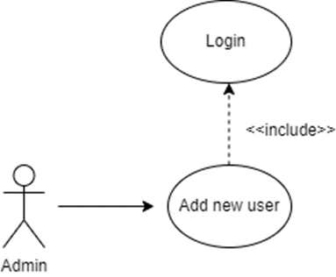

|  |  |
| --- | --- |
| Property | Value |
| ID, Name | UC2.1, Add new user. |
| Goal | Users should be added to the list of users. |
| Initiator | Admin. |
| Precondition | * A user with admin privileges should be logged in. |
| Postcondition | * Users should be added to the list of users. |

#### Step-by-step Description

|  |  |
| --- | --- |
| 1. The system checks that the actor is a user with admin privileges. 2. If the actor isn’t an admin, the system denies their access. 3. If the actor is an admin, the system redirects them to the “add user page.” 4. The admin proceeds to add a user to the list and enters all the details related to the user. 5. The user is then added to the database in a new row. 6. A success message is sent to the admin if the project is successfully added to the database. |  |

### View Users

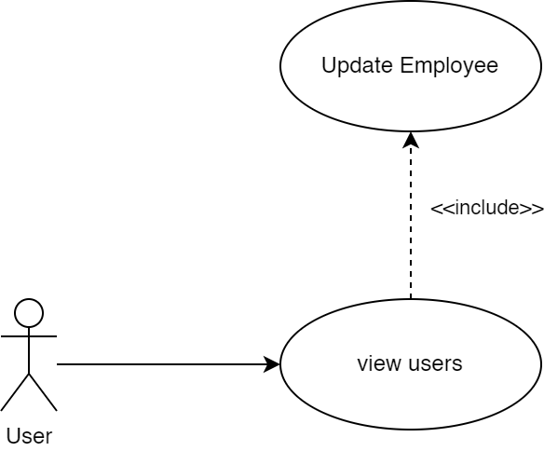

|  |  |
| --- | --- |
| Property | Value |
| ID, Name | UC2.2, View users |
| Goal | view data of users for the user |
| Initiator | Admin |
| Precondition | * A user with admin privileges should be logged in. |
| Postcondition | * Employees data is returned to the user if found |

#### Step-by-step Description

|  |  |
| --- | --- |
| 1. The actor requests to view employees. 2. The system runs validation checks, upon the failure of any,   throws an exception.   * 1. The system checks the actor’s login validity.   2. The system verifies the query parameters of the request.  1. The system queries the database to get employees data with the given filter if exists. 2. The system returns a response carrying a success code   and all employee’s data. |  |

### Update User

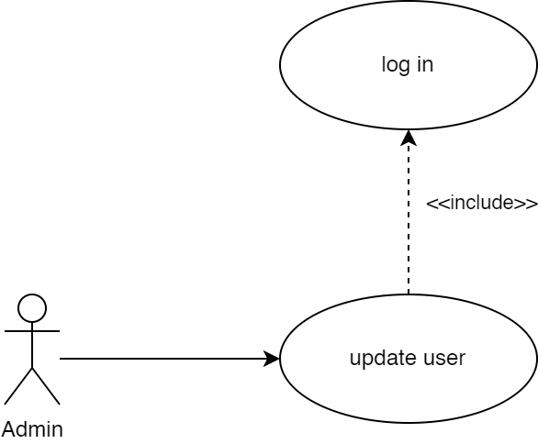

|  |  |
| --- | --- |
| Property | Value |
| ID, Name | UC2.3, Update user |
| Goal | Inputted changes should apply to the table of users. |
| Initiator | Admin |
| Precondition | * A user with admin privileges should be logged in. |
| Postcondition | * The user’s properties will be updated. * The new user data will be returned in response. |

#### Step-by-step Description

|  |  |
| --- | --- |
| 1. The actor submits an update request to update one of the users. 2. The system runs validation checks, upon the failure of any, throws an exception.    1. The system checks the actor’s login validity.    2. The system checks that the actor is either the project leader assigned to this project or a user with higher privileges.    3. The system verifies the input format of the request. 3. The system queries the database to update the given user’s properties with the new data. 4. The system returns a response carrying a success code and the updated user’s data. |  |

### Delete User

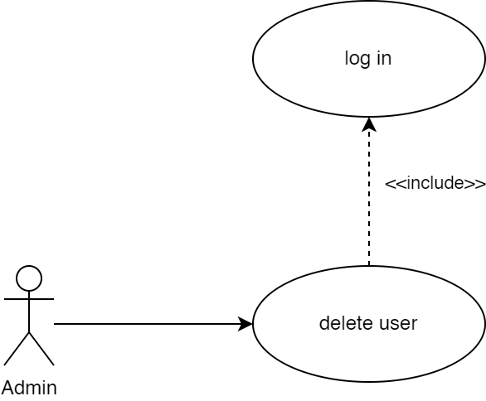

|  |  |
| --- | --- |
| Property | Value |
| ID, Name | UC2.4, Delete user |
| Goal | The given user should be deleted |
| Initiator | Admin |
| Precondition | * A user with admin privileges should be logged in. |
| Postcondition | * The user is deleted from the database. * The deleted user’s data is returned. |

#### Step-by-step Description

|  |  |
| --- | --- |
| 1. The actor submits a delete request to delete one of the users. 2. The system runs validation checks, upon the failure of any, throws an exception.    1. The system checks the actor’s login validity.    2. The system checks that the actor is an admin.    3. The system verifies the input format of the request. 3. The system queries the database to delete the given user. 4. The system returns a response carrying a success code and the delete user data. |  |

### Add Employee

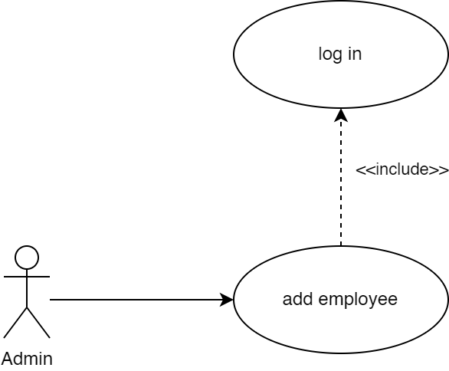

|  |  |
| --- | --- |
| Property | Value |
| ID, Name | UC3.1, Add new Employee. |
| Goal | Employee should be added to the database. |
| Initiator | Admin. |
| Precondition | * A user with admin privileges should be logged in. |
| Postcondition | * An employee should be added to the database. * The new employee’s data should be returned. |

#### Step-by-step Description

|  |  |
| --- | --- |
| 1. The actor sends a request to add a new employee. 2. The system runs validation checks, upon the failure of any, throws an exception.    1. The system checks the actor’s login validity.    2. The system checks that the actor is an admin.    3. The system verifies the input format of the request. 3. The system adds the new employee to the database. 4. The system returns a response with a success code and the new employee’s data |  |

### View Employees

|  |  |
| --- | --- |
| Property | Value |
| ID, Name | UC3.2, View employees |
| Goal | view data of employees for the user |
| Initiator | User |
| Precondition | * The user should be logged in |
| Postcondition | * Employees data is returned to the user if found |

#### Step-by-step Description

|  |  |
| --- | --- |
| 1. The actor requests to view employees. 2. The system runs validation checks, upon the failure of any,   throws an exception.   * 1. The system checks the actor’s login validity.   2. The system verifies the query parameters of the request.  1. The system queries the database to get employees data with the given filter if exists. 2. The system returns a response carrying a success code   and all employee’s data. |  |

### Update Employee

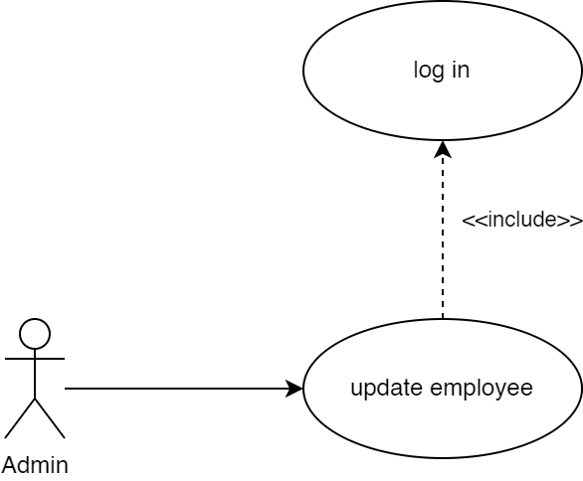

|  |  |
| --- | --- |
| Property | Value |
| ID, Name | UC3.3, Update Employee. |
| Goal | Employee data will be updated in the database. |
| Initiator | Admin. |
| Precondition | * A user with admin privileges should be logged in. |
| Postcondition | * An employee should be added to the database. * The updated employee’s data should be returned. |

#### Step-by-step Description

|  |  |
| --- | --- |
| 1. The actor sends a request to update an employee. 2. The system runs validation checks, upon the failure of any, throws an exception.    1. The system checks the actor’s login validity.    2. The system checks that the actor is an admin.    3. The system verifies the input format of the request. 3. The system updates the employee’s data in the database. 4. The system returns a response with a success code and the updated employee’s data. |  |

### Delete Employee

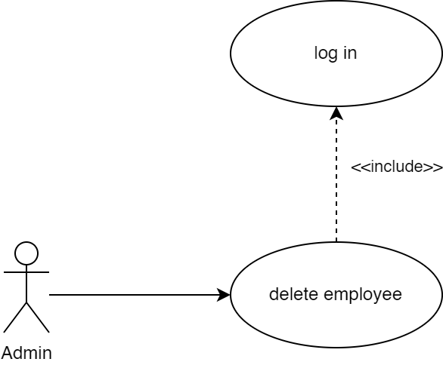

|  |  |
| --- | --- |
| Property | Value |
| ID, Name | UC3.4, Delete Employee. |
| Goal | Employee data will be deleted. |
| Initiator | Admin. |
| Precondition | * A user with admin privileges should be logged in. |
| Postcondition | * The employee is deleted from the database. * The deleted employee’s data is returned |

#### Step-by-step Description

|  |  |
| --- | --- |
| 1. The actor submits a delete request to delete one of the employees. 2. The system runs validation checks, upon the failure of any, throws an exception.    1. The system checks the actor’s login validity.    2. The system checks that the actor is an admin.    3. The system verifies the input format of the request. 3. The system queries the database to delete the given employee. 4. The system returns a response carrying a success code and the deleted employee’s data. |  |

### View Cross-utilized Employees

|  |  |
| --- | --- |
| Property | Value |
| ID, Name | UC3.2.1, View cross-utilized employees |
| Goal | view data of cross-utilized employees |
| Initiator | User |
| Precondition | * The user should be logged in |
| Postcondition | * data of cross-utilized employees is returned to the user if found |

#### Step-by-step Description

|  |  |
| --- | --- |
| 1. The actor requests to view cross-utilized employees. 2. The system runs validation checks, upon the failure of any,   throws an exception.   * 1. The system checks the actor’s login validity.   2. The system verifies the query parameters of the request.  1. The system queries the database to get data of cross-utilized employees with a given filter if exists. 2. The system returns a response carrying a success code   and data of cross-utilized employees if found. |  |

### View Over-utilized Employees

|  |  |
| --- | --- |
| Property | Value |
| ID, Name | UC3.2.2, View over-utilized employees |
| Goal | view data of over-utilized employees |
| Initiator | User |
| Precondition | * The user should be logged in |
| Postcondition | * data of over-utilized employees is returned to the user if found |

#### Step-by-step Description

|  |  |
| --- | --- |
| 1. The actor requests to view over-utilized employees. 2. The system runs validation checks, upon the failure of any,   throws an exception.   * 1. The system checks the actor’s login validity.   2. The system verifies the query parameters of the request.  1. The system queries the database to get data of over-utilized employees with a given filter if exists. 2. The system returns a response carrying a success code   and data of over-utilized employees if found. |  |

### Add Project

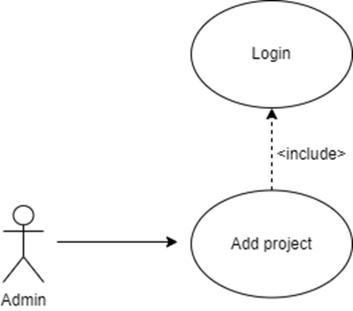

|  |  |
| --- | --- |
| Property | Value |
| ID, Name | UC4.1, Add project |
| Goal | Adding a project to the project list |
| Initiator | Admin |
| Precondition | * A user with admin privileges should be logged in. |
| Postcondition | * A project should be added to the project list by the logged in admin. |

#### Step-by-step Description

|  |  |
| --- | --- |
| 1. The system checks that the actor is a user with admin privileges. 2. If the actor isn’t an admin, the system denies their access. 3. If the actor is an admin, the system redirects them to the “add project page.” 4. The admin proceeds to add a project to the list and enters all the details related to the project. 5. The project is then added to the database in a new row. 6. A success message is sent to the admin if the project is successfully added to the database. |  |

### View Projects

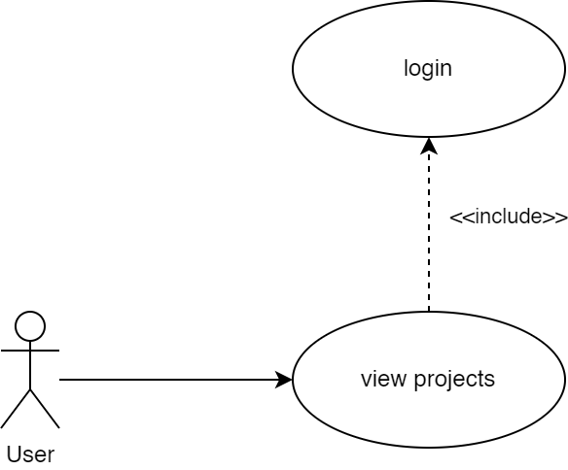

|  |  |
| --- | --- |
| Property | Value |
| ID, Name | UC4.2, View projects |
| Goal | view data of projects for the user |
| Initiator | User |
| Precondition | * The user should be logged in |
| Postcondition | * Projects data is returned to the user if found |

#### Step-by-step Description

|  |  |
| --- | --- |
| 1. The actor requests to view other projects request. 2. The system runs validation checks, upon the failure of any,   throws an exception.   * 1. The system checks the actor’s login validity.   2. The system verifies the query parameters of the request.  1. The system queries the database to get projects data. 2. The system returns a response carrying a success code   and projects data. |  |

### Update Project

|  |  |
| --- | --- |
| Property | Value |
| ID, Name | UC4.3, Update project |
| Goal | Inputted changes should apply to the project table. |
| Initiator | Project Leader, Admin |
| Precondition | * A user with project leader or higher privileges should be logged in. * The project leader must be the team leader of this project. |
| Postcondition | * The project’s properties will be updated. * The new project data will be returned in response. |

#### Step-by-step Description

|  |  |
| --- | --- |
| 1. The actor submits an update request to update one of his projects. 2. The system runs validation checks, upon the failure of any, throws an exception.    1. The system checks the actor’s login validity.    2. The system checks that the actor is either the project leader assigned to this project or a user with higher privileges.    3. The system verifies the input format of the request. 3. The system queries the database to update the given project’s properties with the new data. 4. The system returns a response carrying a success code and the updated project data. |  |

### Delete Project

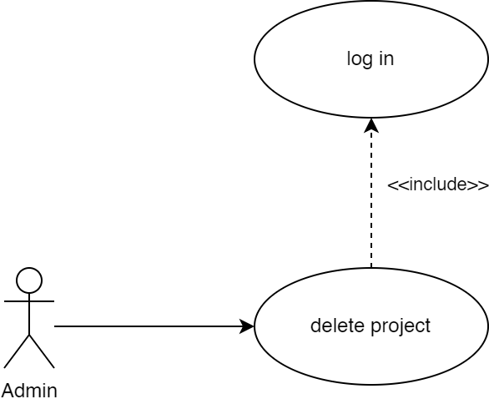

|  |  |
| --- | --- |
| Property | Value |
| ID, Name | UC4.4, Delete project |
| Goal | The given project should be deleted |
| Initiator | Admin |
| Precondition | * A user with admin privileges should be logged in. |
| Postcondition | * The project is deleted from the database. * The deleted project’s data is returned |

#### Step-by-step Description

|  |  |
| --- | --- |
| 1. The actor submits a delete request to delete one of the projects. 2. The system runs validation checks, upon the failure of any, throws an exception.    1. The system checks the actor’s login validity.    2. The system checks that the actor is an admin.    3. The system verifies the input format of the request. 3. The system queries the database to delete the given project. 4. The system returns a response carrying a success code and the deleted project’s data. |  |

### Assign Project Leaders

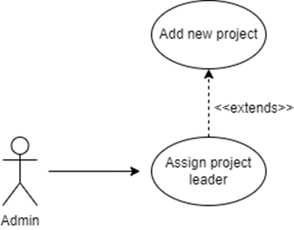

|  |  |
| --- | --- |
| Property | Value |
| ID, Name | UC4.1.1, Assign project leaders. |
| Goal | A project leader should be assigned to a project. |
| Initiator | Admin. |
| Precondition | * A user with admin privileges should be logged in. |
| Postcondition | * A project leader should be assigned to a project. |

#### Step-by-step Description

|  |  |
| --- | --- |
| 1. The system checks that the actor is a user with admin privileges. 2. If the actor isn’t an admin, the system denies their access. 3. If the actor is an admin, the system redirects them to the “assign project leaders page.” 4. The admin proceeds to assign a project leader to a project and enters all the details required. 5. The project leader is then added to the list of project leaders in the database table. 6. A success message is sent to the admin if the project leader is successfully added to the database. |  |

### Add employees to project teams

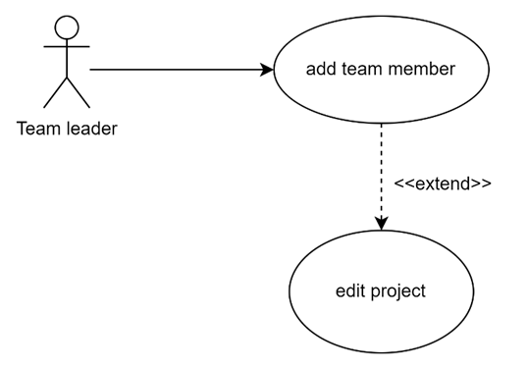

|  |  |
| --- | --- |
| Property | Value |
| ID, Name | UC4.3.1, Add Employees To Project Teams |
| Extends | Update Project |
| Goal | An employee is added to the team of the given project. |
| Initiator | Project Leader |
| Precondition | * A user with project leader should be logged in. * The project leader must be the team leader of the given project. |
| Postcondition | * The employee is added to the given project’s team. * The project team data will be returned in response. |

#### Step-by-step Description

|  |  |
| --- | --- |
| 1. The project leader searches for employees using search filters 2. The system shows the team leader a list of employees based on the filters 3. The project leader submits an update request to add a team member to one of the projects that they’re leading. By selecting an employee from the list of employees with optional filters. 4. The system runs validation checks, upon the failure of any, throws an exception.    1. The system checks the actor’s login validity.    2. The system checks that the inputted project’s leader is the logged in actor.    3. The system verifies the input format of the request. 5. The system queries the database to update the given project’s team members and add the new member 6. The system returns a response carrying a success code and the updated project data. |  |

### Mark Project as done

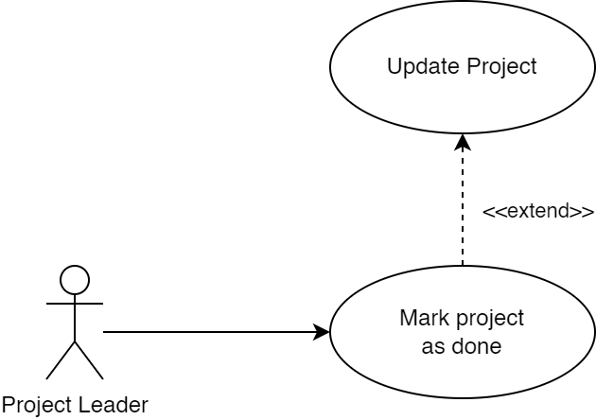

|  |  |
| --- | --- |
| Property | Value |
| ID, Name | UC4.3.2, Mark project as done |
| Extends | Update project |
| Goal | A project’s status is updated to done. |
| Initiator | Project Leader |
| Precondition | * A user with project leader or higher privileges should be logged in. * A project leader must be the team leader of this project. |
| Postcondition | * The project’s status will be updated. * The new project’s data will be returned in response. |

#### Step-by-step Description

|  |  |
| --- | --- |
| 1. The project leader submits an update request to update the status field of one of the projects that they’re leading. 2. The system runs validation checks, upon the failure of any, throws an exception.    1. The system checks the actor’s login validity.    2. The system checks that the inputted project’s leader is the logged in actor.    3. The system verifies the input format of the request. 3. The system queries the database to update the given project’s status with the done status that indicates that this project does not currently utilize any employees. 4. The system returns a response carrying a success code and the updated project data. |  |

### Update Project Capacity

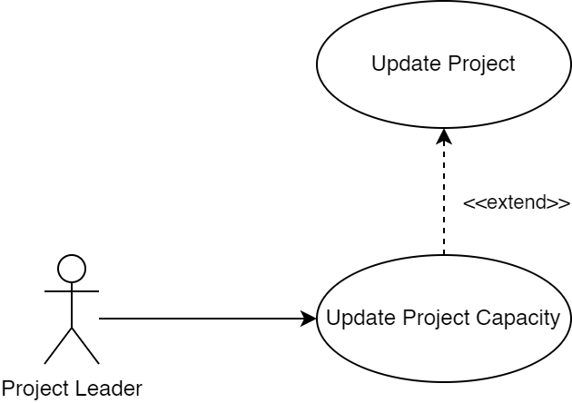

|  |  |
| --- | --- |
| Property | Value |
| ID, Name | UC4.3.3, Update project capacity |
| Extends | Update project |
| Goal | A project’s status is updated to done. |
| Initiator | Project Leader |
| Precondition | * A user with project leader or higher privileges should be logged in. * A project leader must be the team leader of this project. |
| Postcondition | * The project’s capacity is updated. * The new project data will be returned in response. |

#### Step-by-step Description

|  |  |
| --- | --- |
| 1. The project leader submits an update request to update the capacity field of one of the projects associated with one of his projects. 2. The system runs validation checks, upon the failure of any, throws an exception.    1. The system checks the actor’s login validity.    2. The system checks that the inputted project’s leader is the logged in actor.    3. The system verifies the input format of the request. 3. The system queries the database to update the given project’s capacity with the inputted capacity that indicates that this project needs a given number of employees on its team. 4. The system returns a response carrying a success code and the updated project data. |  |

### Update Employee Utilization on Project

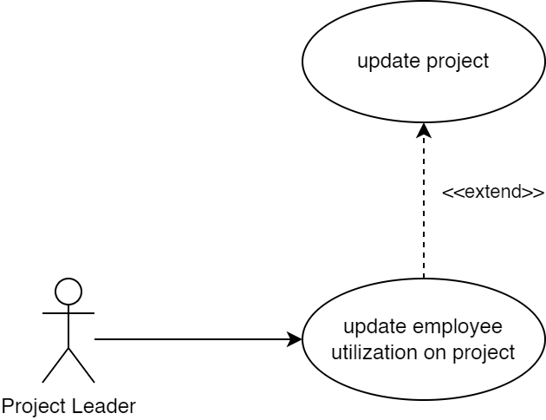

|  |  |
| --- | --- |
| Property | Value |
| ID, Name | UC4.3.4, Update project capacity |
| Extends | Update project |
| Goal | A project’s status is updated to done. |
| Initiator | Project Leader |
| Precondition | * A user with project leader or higher privileges should be logged in. * A project leader must be the team leader of this project. |
| Postcondition | * The employee’s utilization on the given project is updated. * The new employee’s utilization data will be returned in response. |

#### Step-by-step Description

|  |  |
| --- | --- |
| 1. The project leader submits an update request to update the utilization field of one of the employees on one of his projects. 2. The system runs validation checks, upon the failure of any, throws an exception.    1. The system checks the actor’s login validity.    2. The system checks that the inputted project’s leader is the logged in actor.    3. The system verifies the input format of the request. 3. The system queries the database to update the utilization field of the employee’s utilization on the project. 4. The system returns a response carrying a success code and the updated employee’s utilization data. |  |

### View statistical details

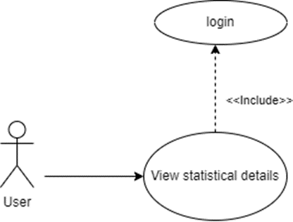

|  |  |
| --- | --- |
| Property | Value |
| ID, Name | UC5, View statistical details |
| Goal | views statistical data of sorts for the user |
| Initiator | User |
| Precondition | * The user should be logged in |
| Postcondition | * The system will aggregate statistical analysis and send it to user |

#### Step-by-step Description

|  |  |
| --- | --- |
| 1. The actor submits a view statistical details request. 2. The system runs validation checks, upon the failure of any,   throws an exception.   * 1. The system checks the actor’s login validity.   2. The system verifies the query parameters of the request.  1. The system queries the database to get statistics data. 2. The system returns a response carrying a success code and the statistics data. |  |

## Sequence Diagrams

### Add new Project

* See use case: UC4.1

### Add New User

* See use case: UC2.1

### Assign Employee to project

* See use case: UC4.3.1

### Update employee utilization On Project

* See use case: UC4.3.4

### View employees

* See use case: UC3.2

### View Projects

* See use case: UC4.2

### View project statistics

* See use case: UC5

### View Employee Statistics

* See use case: UC5

# Designs

## Class Diagram

## Object Diagram

## Database Physical Design

# Prototype

## Admins can manage users' data.

* Add a user:

* Edit user:

* View user:

## Admins can manage projects' data.

* Add a project:

* Edit a project:

* View a project:

## Team leaders can add or remove employees to their team.

## Team leaders can add the required employee capacity to their team members.

## Team leaders and Admins can view a List of all the projects and their data

## Admins and team leaders can view statistical details

## Admins can manage employees

1. Add employee:

1. Edit employee:

1. View employee:

